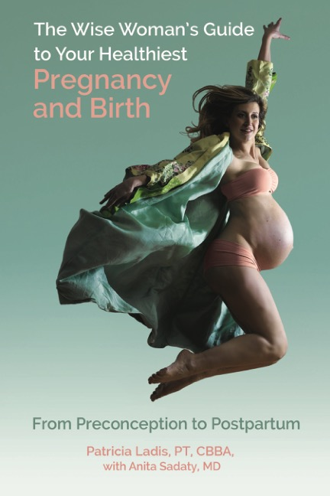

Wise Woman’s Guide to Your Healthiest Pregnancy and Birth
By Patricia Ladis, PT, CBBA and Anita Sadaty, MD

The Wise Woman’s Guide to Your Healthiest Pregnancy and Birth brings together evidence-based science, ancient wisdom, breathing and lifestyle medicine for the first time in a joyful, holistic guide to preconception, pregnancy and postpartum.

The biggest necessity for a pregnant woman is to feel supported, and this book supports women physically, emotionally and spiritually, helping them to connect with their innate intuition while sharing the latest in science-backed health information. The Wise Woman’s Guide to Your Healthiest Pregnancy and Birth is divided into seven chapters: preconception, first trimester, second trimester, third trimester, delivery, the first forty days after delivery, and beyond 40 days. Each chapter includes five sections that bring together the key elements of this integrated approach for each stage of pregnancy:

- Your Body. A wise woman needs to prepare her mind and body for pregnancy. The mother’s health and well-being during every stage is directly connected to the growth and health of the baby and influences their disease risk for years to come. This section provides thoroughly researched medical information and lifestyle suggestions to proactively set the stage for a healthy pregnancy and a healthy baby.
​
- Restorative Breathing. Here’s a fact: 100 percent of pregnant women have a breathing dysfunction because they cannot access their diaphragm in order to breathe properly. These sections will share guidance on how to breathe efficiently during pregnancy and birth in order to compensate in a positive way.

- Movement. Every wise woman, regardless of her current fitness level, must strengthen the deep muscles that support her core, spine, and pelvis in order to ensure a pregnancy and delivery free from unnecessary pain and injury. The movement sections will explore how to work these specific muscles and once and for all shatter the recurring myths and misconceptions surrounding when to exercise during pregnancy.

- Nourishment. A wise woman doesn’t want to count calories. Instead, she wants a comprehensive nutrition program that establishes ideal eating patterns and food choices that best support conception, pregnancy, breastfeeding and getting that pre-baby body back. This section factors in the pregnancy stage, dietary restrictions, hereditary background and more.

- Wisdom. Each chapter will include “pearls of wisdom” gleaned from historical as well as multicultural perspectives that are backed by the latest science. These range from different techniques for improving sleep and continuing sexual activity to setting up a personal team and planning for the future.

When wise women and their partners are calm, fit and well-nourished – emotionally and physically – they are more likely to experience the journey to parenthood as the joyous and miraculous milestone it should be. Let The Wise Woman’s Guide to Your Healthiest Pregnancy and Birth be a source of strength, connection, confidence and wisdom.

About the Authors

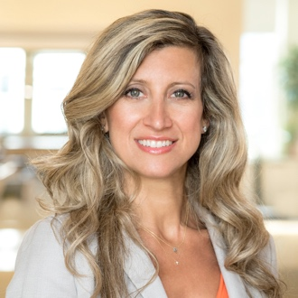
Patricia Ladis, PT, CBBA is a licensed physical therapist and author of Wise Woman’s Guide to Your Healthiest Pregnancy & Birth. Founder of WiseBody Physical Therapy, Patricia previously co-founded the KIMA Center for Physiotherapy & Wellness, one of New York City’s most highly regarded PT and wellness centers. She is also co-founder of The First 1000 Days of Wellness, a global educational platform for practitioners, spas and consumers to promote perinatal wellness and prevent non-communicable diseases in future generations. Read more here.

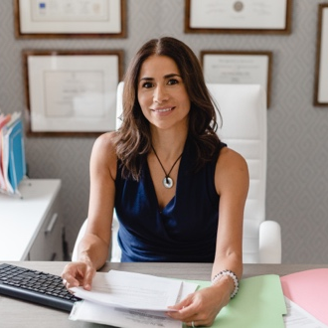
Anita Sadaty, MD is a holistic practitioner and founder of Redefining Health Medical, a women-focused medical practice that combines conventional medical training with an integrative functional medicine approach. A graduate of Cornell Medical and a board-certified ob-gyn, Dr. Sadaty is also recognized as a Certified Medical Practitioner by the Institution for Functional Medicine. She was a founding member of the Kresser Institute ADAPT Functional Medicine Training program in 2016. In addition to maintaining a full-time private practice, Dr. Sadaty is involved in residency training education at Northwell Hospital and is a clinical assistant professor at Hofstra Medical School. She serves as an expert reviewer for women’s reproductive health articles featured in Verywellhealth.com and was recently named as one of the best Obstetrics and Gynecology physicians on Long Island, New York in Best of Long Island. She has appeared in numerous newspaper articles, magazines, and professional publications to discuss various topics in women’s health. Visit her website at www.drsadaty.com.

For more information or to book an appointment with WiseBody Physical Therapy, please visit PatriciaLadis.com.

Click here to order Wise Woman’s Guide to Your Healthiest Pregnancy & Birth.

